* If you are making use of jpa repository then its Mandotary to add @EnableJpaRepositories, h2 console was not opening after adding this annotation jpa started working and h2 console also opened
* If you are using swagger open api then don't use springdoc-openapi-ui instead use springdoc-openapi-starter-webmvc-ui
* 406 error not acceptable

Always add getters and setters in response dto else it will give 406 error

* Invoking getters and setters method

While invoking getters method its ok to call getMethod of class object but while invoking setter method you need to call getDeclaredMethod bcoz you need to pass arguments type below is the code for same.

* private void setUpdatedValue(EmployeeEntity entity, EmployeeReqDto req) {

  Class<? extends Object> reqcls = req.getClass();

  Class<? extends Object> entcls = entity.getClass();

  try {

   Method declaredMethod = reqcls.getMethod("get"+getMethodName(req.getKeyName()));

   Object value = declaredMethod.invoke(req, null);

   declaredMethod = entcls.getDeclaredMethod("set"+getMethodName(req.getKeyName()),String.class);

   declaredMethod.invoke(entity, value);

  } catch (Exception e) {

   e.printStackTrace();

  }

 }

**private** String getMethodName(String key) {

**return** key.substring(0, 1).toUpperCase()+key.substring(1);

}

* Working on AOP

Was getting null when method is returning value if Around advice is used and we are just proceed on pointcut with out returning then all our methods will also return null. Hence we need to return value from pointcut as below.

As you can see in below snap shot I’m not returning anything from aspect method just calling jointpoint.proceed(). Hence even our methods will start returning void

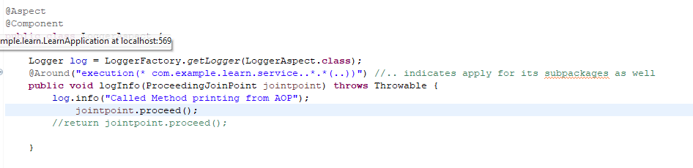

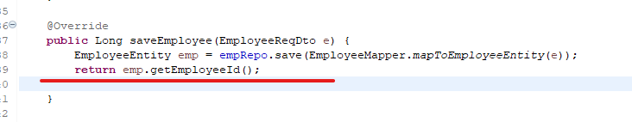

This will start returning null

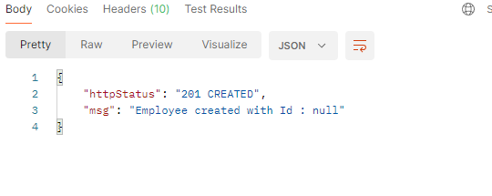

Hence we need to return an object from point cut as below updated the above AOP code

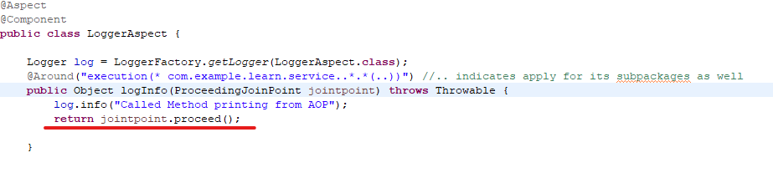

<https://docs.spring.io/spring-framework/reference/core/aop/ataspectj/advice.html#aop-ataspectj-around-advice>